Identity of floor and ceiling

[Math/Math_Floor_Ceiling.docx at main · mathGeeks/Math (github.com)](https://github.com/mathGeeks/Math/blob/main/Symbols/Operation/Real%20Number/Floor/Math_Floor_Ceiling.docx)

$$Rounding a number by floor get the result$$

$$which is biggest but is smaller than the number.$$

$$Rounding a number by floor get the result$$

$$which is smallest but is bigger than the number.$$

$$\left[figure\right]$$

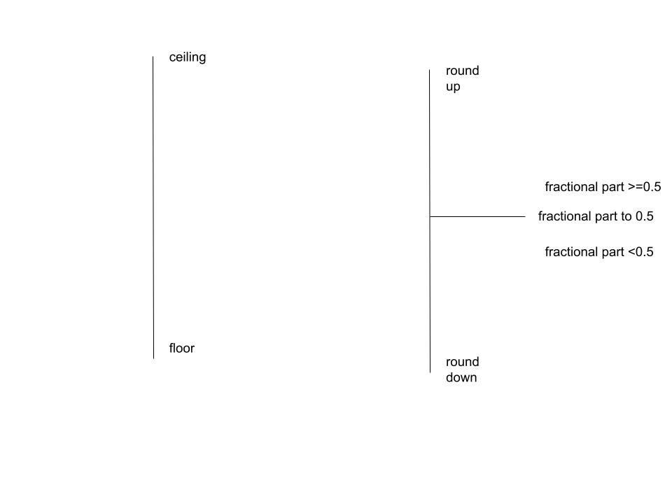

$$\left[symbol\right]$$

|  |  |  |  |
| --- | --- | --- | --- |
| $$Symbol$$ |  |  | $$\{ \}$$ |
| $$Meaning$$ | $$Floor$$ | $$Ceiling$$ | $$Fractional part$$ |
| $$Example$$ | $$\left\lfloor π\right\rfloor$$ | $$\left\lceil π\right\rceil$$ | $$\{π\}$$ |
| $$Description$$ | $$Floor of π$$ | $$Ceiling of π$$ | $$Fractional part of π$$ |
| $$Result$$ | $$3$$ | $$4$$ | $$π-3$$ |

$$\left[identity\right]$$

$$In this section, I will only discuss the identities.$$

$$I will NOT prove it.$$

$$For any real number x,$$

$$1.About floor,$$

$$(1)x≤\left\lfloor x\right\rfloor <x+1$$

$$\left(2\right)x=\left\lfloor x\right\rfloor iff x is an integer.$$

$$\left(3\right)x=\left\lfloor x\right\rfloor +\left\{x\right\} iff x≥0$$

$$2.About ceiling,$$

$$(1)x-1<\left\lceil x\right\rceil ≤x$$

$$\left(2\right)\left\lceil x\right\rceil =x iff x is an integer.$$

$$\left(3\right)x=\left\lceil x\right\rceil -\left\{x\right\} iff x<0$$

Ref:

[Floor and ceiling functions - Wikipedia](https://en.wikipedia.org/wiki/Floor_and_ceiling_functions)